PROFESSIONAL PROGRAMME EXAMINATION DECEMBER 2025 SESSION
RANK | ROLL NO. | NAME OF THE STUDENT | ADDRESS | PHOTO
1 | 321918 | KINJAL AJMERA | KOLKATA, WEST BENGAL | 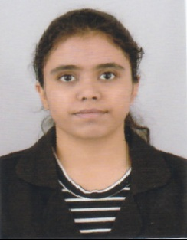
2 | 305210 | MANYA BATHLA | SAHARANPUR, UTTAR PRADESH | 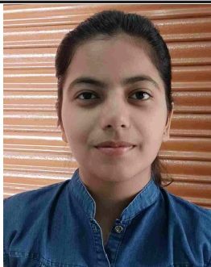
3 | 320848 | CHARU UPADHYAY | JABALPUR, MADHYA PRADESH | 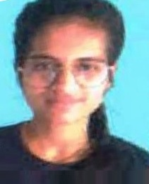

EXECUTIVE PROGRAMME EXAMINATION DECEMBER 2025 SESSION
Rank | ROLL NO. | NAME OF THE STUDENT | ADDRESS | PHOTO
1 | 140157 | ANISHA DARSHAN KESWANI | AHMEDABAD, GUJARAT | 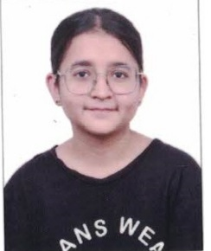
2 | 146145 | SIDDHI KHANDELWAL | INDORE, MADHYA PRADESH | 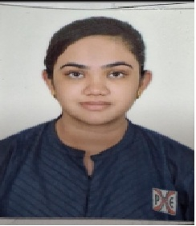
3 | 159546 | RANGVALA INSIYA IMARAN BAHI | JETPUR, GUJARAT | 